CockpitHardwareHUB_v2

# Tool for Cockpit Builders to connect hardware to Microsoft Flight Simulator 2020

There are many tools available to connect flight simulator hardware to MSFS 2020. But a lot of these tools (most of them?) require some configuration before the connected hardware can work. Other tools only work with one specific brand of microcontrollers (example: Arduino).

This is where CockpitHardwareHUB_v2 comes in with 2 main advantages:

* It works with any microcontroller, as long as it provides a serial interface through USB
* Each device “pushes” its own configuration requirements, without the need of extra maintenance

Although, CockpitHardwareHUB_v2 requires that you write your own software for your hardware. But that of course provides endless flexibility.

The first version of [CockpitHardwareHUB](https://github.com/HansBilliet/CockpitHardwareHUB) made use of its own WASM module. CockpitHardwareHUB_v2 uses an adapted version of the WASM module based on [WASimCommander](https://github.com/mpaperno/WASimCommander) written by [mpaperno](https://github.com/mpaperno/WASimCommander).

# Concept of CockpitHardwareHUB_v2

Once CockpitHardwareHUB_v2 is started, it listens to ‘Win32_SerialPort’ devices. When hardware is connected, it is identified by the PNPDevice string with the following format:

USB\VID_vvvv&PID_pppp\nnnnnnnn

This string contains the following elements:

|  |  |
| --- | --- |
| USB | This indicates that it is a USB device |
| VID_vvvv | This is the VendorID of the device in a 16 bit hexadecimal format |
| PID_pppp | This is the ProductID of the device in a 16 bit hexadecimal format |
| nnnnnnnn | This is the serial number of the device |

For CockpitHardwareHUB_v2 to work correctly, each device should be unique. That means that at least the serial number should be different for each device.

*// Future change: Allow to filter on a specific VendorID/ProductID*

Once a device is detected, a ‘Registration Process’ takes place. For this, CockpitHardwareHUB_v2 will send some commands to the device and expect some answers.

|  |  |
| --- | --- |
| **Command** | **Reaction by device** |
| RESET\n | Brings the device in 'Registration Mode' |
|  | Here is a delay of 200 msec |
| IDENT\n | Device answers with its DeviceName followed by '\n' |
|  | Device answers with its ProcessorType followed by '\n' |
| REGISTER\n | Device starts sending all its Property strings one by one followed by '\n' |
|  | If no more properties, device sends final '\n' (empty string) |

Once all properties are successfully received, they are added in the Property Pool where they become ‘Variables’. These variables are then registered with MSFS using SimConnect and/or the WASM module. If different devices register the same property, then the same variable is used in CockpitHardwareHUB_v2. This avoids that unnecessary registrations are done, which could be a waste of resources and slow down the system.

From then onwards, properties are identified by ‘Property Id’, which is the order of which the Properties have been registered, starting at 1. CockpitHardwareHUB_v2 translates these in its own internal numbering system for the variables. Working with numbers is a lot more efficient in microcontroller hardware, in which comparing with a number is faster than comparing with strings.

The power of CockpitHardwareHUB_v2 lays in the fact that each ‘Device Property’ contains all the information needed to instruct MSFS what is required. This replaces the configuration files that you need in other tools. It means that each device is ‘self-containing’, which gives the advantage that when you develop your device, you can make changes in properties on the fly without having to adapt configuration files somewhere else. CockpitHardwareHUB_v2 doesn’t need any configuration depending on the devices connected to it. Each time you disconnect and reconnect the device, the previous registrations are removed, and the new registrations are loaded.

# Construction of a ‘Device Property’

The property strings returned by the device always have the below format:



* ValueType: This is the type of the value of the property. CockpitHardwareHUB_v2 will check if the value fits in the type.
* RW: This indicates if the variable is a ‘R’ead (means that MSFS needs to send the value to your device) or ‘W’rite (means that the device sends data to MSFS). A variable can be both Read and Write.  
  In case the ValueType is ‘VOID’, then the ‘_[R][W]’ should not be included.
* VarType: These are the variable types that are currently supported:
  + A: These are ‘[Simulation Variables](https://docs.flightsimulator.com/html/Programming_Tools/SimVars/Simulation_Variables.htm)’
  + L: These are ‘Local Variables’
  + K: These are events. If an event has a ‘.’ in the VarName, then it is a ‘Custom Event’ (example: A32NX.FCU_SPD_INC). Otherwise it is a normal ‘[key events](https://docs.flightsimulator.com/html/Programming_Tools/Event_IDs/Event_IDs.htm)’.
  + X: These are variables that are using the Gauge API function ‘[execute_calculator_code’](https://docs.flightsimulator.com/html/Programming_Tools/WASM/Gauge_API/execute_calculator_code.htm).
* VarName: This is the name of the variable
* Extension (optional): Some variables have an extension, which added by a colon and the extension number (example: LIGHT POTENTIOMETER:84).
* Unit (only for VarType ‘A’): Only A-Vars need a unit.

Some examples of Property strings:

|  |  |
| --- | --- |
| **ID** | **Property** |
| 001 | INT32_R_A:LIGHT STROBE,bool |
| 002 | INT32_RW_L:LIGHTING_LANDING_2 |
| 003 | VOID_K:A32NX.FCU_SPD_INC |
| 004 | INT32_R_A:LIGHT POTENTIOMETER:84,percent |
| 005 | VOID_K:LIGHT_POTENTIOMETER_SET |
| 006 | VOID_K:ANTI_ICE_TOGGLE_ENG1 |
| 007 | STRING16_R_X:(A:ATC FLIGHT NUMBER,string) |
| 008 | STRING64_R_X:(A:TITLE,string) |

CockpitHardwareHUB_v2 applies some restrictions per VarType:

* ‘A’-Var
  + Can only be INT8, INT16, INT32, INT64, FLOAT32 and FLOAT64
  + ‘Unit’ is mandatory and needs to be recognized by MSFS/WASimCommander
* ‘L’-Var
  + Can only be INT8, INT16, INT32, INT64, FLOAT32 and FLOAT64
* ‘K’-Var
  + Can only be INT8, INT16, INT32 or VOID
  + Can only be ‘W’rite
* ‘X’-Var
  + Can not be both ‘R’ead and ‘W’rite
  + Can be parameterized with maximum 5 parameters using {0}, {1}, {2}, {3} and {4}

Also note that ‘VOID’ can’t have a ‘R’ead or ‘W’rite, as it always implies a ‘W’rite operation (is mainly used for ‘K’-Vars).

# Sending and receiving data

Commands have the following format:

NNN[=[data1[;data2;[data3[;data4[;data5]]]]]\n

* NNN is the property number according to the sequence sent by the device during registration, starting with 001.
* ‘=’ -sign normally means that some data will follow. A command can be sent without data, which implies the value 0.
* ‘dataN’ which is the data fitting in the type ValType. A command can have up to 5 values, which are separated by ‘;’-character. For FLOAT type of data, only 3 fractional digits are given.
* Every command is terminated by ‘\n’

A device can only send data to MSFS 2020 for ‘W’rite variables. This means that in the example above, the following variables can be used to send data: 002, 003, 005 and 006.

A will only receive data for ‘R’ead variables. This means that in the example above, the following variables can be used to receive data: 001, 002, 004, 007 and 008.

After all properties have been registered, CockpitHardwareHUB_v2 will send the values of all ‘R’read commands to the device. After that, only the changes are being sent.

Some examples:

* MSFS 2020 can send the string ‘001=0\n’ or ‘001=1\n’, returning the status of the ‘LIGHT STROBE’.
* MSFS 2020 can send the string ‘002=0\n’, ‘002=1\n’ or ‘002=2\n’, depending on the position of the ‘LIGHTING LANDING 2’ switch. Your device can send the same commands back to MSFS 2020 to change the ‘LIGHTING LANDING 2’ switch.
* Your device can send the string ‘003\n’, ‘003=\n’ or ‘003=1\n’ to MSFS 2020 to increase the SPD with one. Be aware that some ‘K’-Vars completely ignore the value (in the above example, ‘003=0\n’ would have the same effect). Also note that the ‘=’ is optional if no value is required (which is typical for a VOID).
* MSFS 2020 can send the string ‘004=50\n’, which indicates that the ‘LIGHT POTENTIOMETER:84’ is at 50 percent. Using the correct ‘Unit’ is important. The variable could have been registered with a FLOAT32 using the unit ‘Enum’, which would return the value 0.5 instead. (It seems that ‘enum’ can be used for a lot of value types).
* Your device can use the string ‘005=84;25\n’ to set the value of ‘LIGHT POTENTIOMETER:84’ to 25%.
* MSFS can send the string ‘007=1123\n’ to return the ‘ATC FLIGHT NUMBER’.
* MSFS can send the string ‘008=Airbus A320 Neo FlyByWire’ to return the ‘TITLE’.

# User Interface made to help developing your hardware

Some research might be required to know what variables are needed and how to use them. This is the typical struggle of every Cockpit Hardware builder. It is well known that the SDK Documentation is not always very clear and might be missing some details. For add-ons, you must refer to the information provided by the owner of the package.

CockpitHardwareHUB_v2 is not only a tool to interface hardware with MSFS 2020, but it also can assist in experimenting with variables before implementing them in your hardware.

The User Interface can be divided in 6 groups:

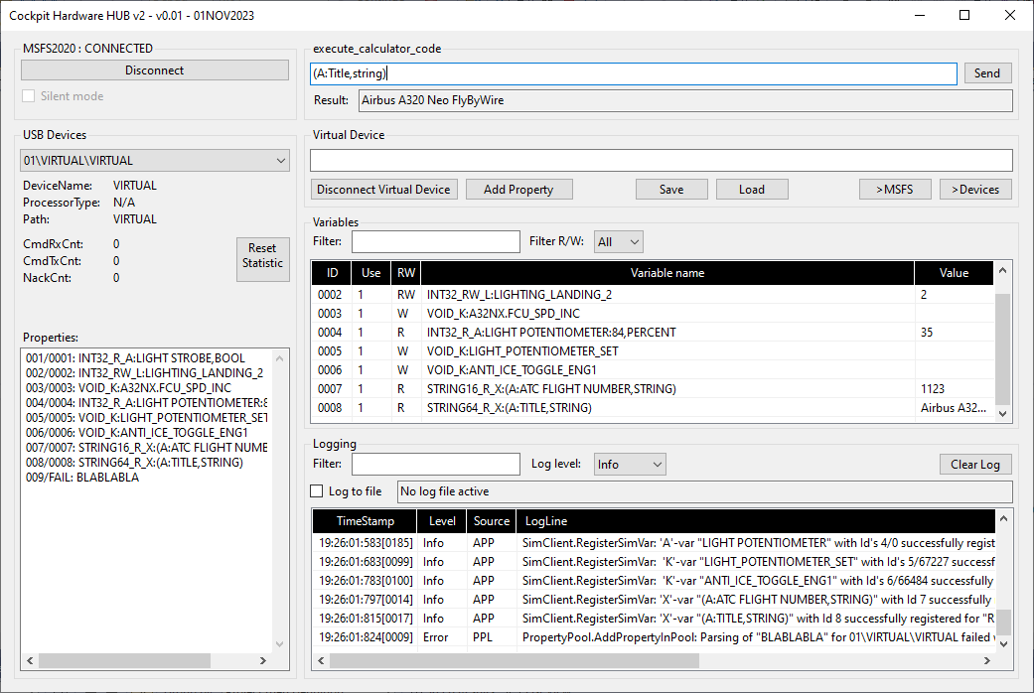

### Connection group

This shows the Connect/Disconnect button. Connecting means that CockpitHardwareHUB_v2 will connect with MSFS 2020 through SimConnect, and will then connect with the WASM module. Only if both connections are successful, CockpitHardwareHUB_v2 considers this as ‘connected’.

If ‘Silent mode’ is enabled, all user interface activity, including logging, is disabled. This improves efficiency and speed, and is used for just ‘flying with the sim’.

### USB Devices

This shows the properties of each detected device. Using the dropdown box, you can switch between registered devices that are shown as ‘DeviceID\Comport\DeviceName’.

For each device you can see the DeviceName and Processortype (see ‘IDENT\n’ command), the full path, and communication statistics CmdRxCnt, CmdTxCnt and NackCnt (which are pretty much self-explanatory). The statistics can be reset by pressing the button ‘Reset Statistics’.

Finally, a list with all registered properties for the selected device. Each entry shows the ‘PropertyID’ which is the command ID used to send data to/from the device, the corresponding ‘Variable ID’, and the full ‘Property String’. If a Property could not correctly be registered (Example: due to some parsing error), the ‘Variable ID’ will show ‘FAIL’.

## execute_calculator_code

This is a very helpful tool to experiment with commands. The Gauge API function ‘execute_calculator_code’ can be used to send all kinds of commands to MSFS, and can if needed return a value. This function uses ‘[Reverse Polish Notation’](https://docs.flightsimulator.com/html/Additional_Information/Reverse_Polish_Notation.htm). In almost all cases, RPN-strings that can be executed, can be registered using an ‘X’-Var in CockpitHardwareHUB_v2, and then be used by your hardware by simply providing the ‘PropertyID’.

Example using FBW A32NX (free) add-on airplane:

The below RPN-sequence will set both Left and Right EFIS to ‘CSTR’.

1 (>L:A32NX_EFIS_L_OPTION,enum) 1 (>L:A32NX_EFIS_R_OPTION,enum)

This RPN string doesn’t return a value, in which case ‘Result’ will show ‘0’.

You can experiment with this sequence and use the other possible values such as 2 (VOR.D), 3 (WPT), 4 (NDB) and 5 (ARPT).

Now you know to use this command, you can use it in your device with the below property string:

VOID_X: 1 (>L:A32NX_EFIS_L_OPTION,enum) 1 (>L:A32NX_EFIS_R_OPTION,enum)

Assuming that this is command 10, your device can send the string ‘010’ to simply put both EFIS left and right to ‘CSTR’.

You can even go one step further by using parameters which are allowed for ‘X’-Vars. The below property string uses 2 parameters. Be aware that when using parameters, you need to provide a ValType (CockpitHardwareHUB_v2 needs to know what type the parameters can be – only restriction is that they all need to be the same type).

INT8_W_X: {0} (>L:A32NX_EFIS_L_OPTION,enum) {1} (>L:A32NX_EFIS_R_OPTION,enum)

Now you can independently control the EFIS left and right. Sending the string ‘010=2;3’ will set the EFIS left to ‘VOR.D’ and the EFIS right to ‘WPT’.

## Virtual Device

This is a second tool to help experimenting to find the correct properties for your device. Once you have identified the correct commands and values (maybe with the help of ‘execute_calculator_code’), you can now go one step further and build property strings.

A Virtual Device just acts as a real USB device connected to your computer. Once you are connected with MSFS 2020, you can ‘Connect Virtual Device’, which will add it to the ‘USB Devices’ group. Once connected, you can perform several actions:

* **Connect/Disconnect Virtual Device**: Once you are connected with MSFS 2020, you can use ‘Connect Virtual Device’, which will add it to the ‘USB Devices’ group. If connected, the other buttons become active. To unregister all properties added to the VIRTUAL device (see below), you have to Disconnect. There is no other way to unregister variables, because they need to stay in sequence (no gaps allowed in the Property ID numbering).
* **Add Property**: This adds the property string from the input field to the virtual device, and registers it. You will get feedback if something is wrong. If all is ok, the property will be added and registered, and will be found in the Property list on the left. This is completely simulating as if your device would receive the “REGISTER” command and is responding with this Property string.
* **Save**: This allows you to save all already registered properties of the VIRTUAL device to a *.txt file.
* **Load**: This appends Property Strings from a *.txt file to the already registered properties in your VIRTUAL device. Be aware that the same property can always be registered twice (there is no added value of course). If you want to remove properties, you will have to Disconnect the VIRTUAL device.

You can easily create your own property files, which are simple text-files with lines of property strings.

## Variables

This ListBox shows all the successfully registered variables. You can filter on ‘Variable Name’ by entering some text an pressing ‘ENTER’. You can also filter on the RW flag (very handy to only show the ‘R’ variables).

You can send a command to MSFS or devices by entering it in the entry field and pressing the ‘>MSFS’ or ‘>Devices’ button. Be aware to use the ‘Variable ID’.

* >MSFS: This is only possible for ‘[R]W’-variables and allows to send a variable and its data to MSFS 2020. It is as if you would send a command from your device to MSFS 2020, but here you directly use the ‘Variable ID’ instead of the ‘Property ID’.
* >Devices: This is only possible for ‘R[W]’-variables and allows to send a variable and its data to all devices that have registered for it (excluding the VIRTUAL device).

The Variable list shows the following information:

* ID: The Variable ID
* Use: The usage count. If more than one device registers for the same variable, the usage count will increase. If a device is disconnected, the usage count of its registered variables will decrease. Once the usage count becomes 0, the variable is unregistered with MSFS 2020.
* Variable name: The full Property String of the variable.
* Value: For Read variables, this shows the value in real time. If you want to see specific Read variables, you can Filter only ‘R’-variables, combined with filtering on the Variable name.

## Logging

This shows all kind of logging information. Although a lot can be pretty cryptic, if the level shows ‘Error’, there is definitely something wrong. You can Filter on the LogLine text and change the Log Level. Be careful with Log Level ‘Trace’ because that will make the UI less responsive. You can Clear the Log by pressing the ‘Clear Log’ button.

You can also log into a file. When enabling this option, you are asked for a filename. Be aware that logging to file can create some performance drop. But it can be handy if you have an issue, and want to send me some logging data allowing me to analyze the issue.

The Logging list shows the following information:

* TimeStamp: This is the time when the LogLine was registered up to msec precision. The difference in msec between this LogLine and the previous one is shown between square brackets. If the difference is 10 seconds or more, ‘[9999]’ is shown. Be aware that sometimes negative values can be shown because logging is in some cases asynchronous.
* Level: Shows the log level. Only logging information of a level higher than the chosen level will be shown.
* Source: This is a code of the source of the Logging information and is only useful for the developer of this application.
  + CLT: WASimCommander Client Module
  + SRV: WASimCommander WASM Module
  + APP: Common application
  + DEV: Related to the COMDevice
  + VAR: Related to the SimVar
  + PPL: Related to the PropertyPool
* LogLine: The logging information

## Credits

CockpitHardwareHUB_v2 is the successor of [CockpitHardwareHUB](https://github.com/HansBilliet/CockpitHardwareHUB). This was the result of several posts that I wrote on the Flight Simulator Forum such as:

* [SimConnect + WASM combined project using VS2019](https://forums.flightsimulator.com/t/simconnect-wasm-combined-project-using-vs2019/486871)
* [Tool to connect Serial USB devices to MSFS2020 via SimConnect/WASM using VS2022](https://forums.flightsimulator.com/t/tool-to-connect-serial-usb-devices-to-msfs2020-via-simconnect-wasm-using-vs2022/514651)
* [My A320 FCU and MCDU finished](https://forums.flightsimulator.com/t/my-a320-fcu-and-mcdu-finished/586170)

Instead of using my own WASM module, CockpitHardwareHUB_v2 makes use of (slightly adapted) version of [WASimCommander](https://github.com/mpaperno/WASimCommander/tree/main), developed by Maxim (Max) Paperno. Max has contributed a lot by answering my numerous emails to understand the internals of his application. Without his patience and efforts (and extremely long and detailed emails), I couldn’t have done this.

Also worth mentioning is ChatGPT 4.0, who has become my daily ‘friend’ to answer several 100 questions about C++ and C# using Visual Studio 2022. Before, ‘Google was my best friend’, but ChatGPT is a lot easier to use, is extremely specific and to the point. Although not all answers are correct, in most cases they were extremely helpful. I consider ChatGPT now as my ‘personal assistant’ 😊

CockpitHardwareHUB_v2 is fully built in Visual Studio 2022.

## Copyright, License and Disclaimer

CockpitHardwareHUB_v2 Project

COPYRIGHT: Hans Billiet; All Rights Reserved.

Licensed under the terms of the GNU General Public License (GPL) as published by the Free Software Foundation, either version 3 of the License, or (at your option) any later version.

General

This program is distributed in the hope that it will be useful, but WITHOUT ANY WARRANTY; without even the implied warranty of MERCHANTABILITY or FITNESS FOR A PARTICULAR PURPOSE. See the GNU General Public License for more details.

Copies of the GNU GPL and LGPL are included with this project and are available at http://www.gnu.org/licenses/.

Except as contained in this copyright notice, the names of the authors or their institutions shall not be used in advertising or otherwise to promote the sale, use, or other dealings in, any product using this Software, or any derivative of this Software, without prior written authorization from the authors.

This project may also use 3rd-party Open Source software under the terms of their respective licenses. The copyright notice above does not apply to any 3rd-party components used within.